**3.3 I can select and use an appropriate programme to upload and publish the web site.**

FileZilla is one programme that can be used to upload web pages onto a host server.

This is done by having a host server to publish your website from, and login details to be able to upload pages and make changes.

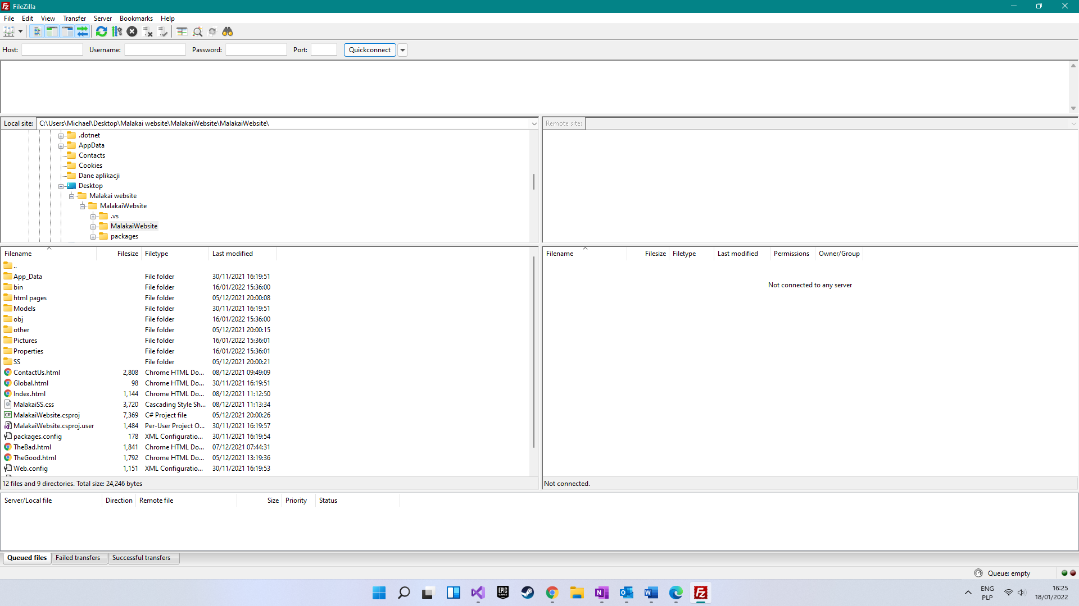

On the left are the files and folders on my own (local) computer. To upload a page or folder I would right click it and select Upload.

On the right side would be the pages and documents that have been successfully uploaded onto the host server. Once this was done I would be able to see my website onto the internet.

The area at the bottom shows the uploads that are queued, not transferred (to the host server) and successfully transferred. This would be populated if one was transferring files from the local storage onto the server.